Javascript primitive data types

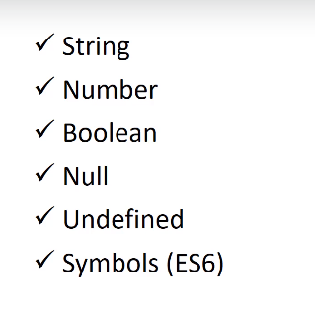

Reference Data Types

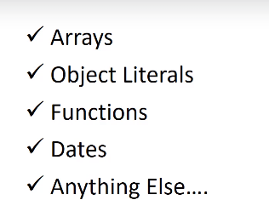

>>>>Dynamically types languages..

Templates literals…:-